**Publishing a Web Service on IIS 7 Server.**

This article hopes to make it clearer on how to publish a web service in an IIS 7 environment.  Its describes creating a new web site to host the web service, as well and adding the web service as an application to an existing web site.

Firstly before you can publish the web service I would have to assume that you have already written your web service code, tested / debugged it and exported the necessary files needed for the web service run. All of this can be done from with in visual studio. This article deals with web services that are written to run in the .NET framework.

Furthermore I am going to have to assume that you have an environment where IIS 7 is installed and already configured to host web sties.

Files needed for a Web service to run

Once you have these files then the next step is to *Create a website* using IIS 7. This can be done from the Internet Information Services (IIS) Management console. The console can be started by one of the 2 following :

**To start IIS Manager from the Run dialog box**

a) On the Start menu, click All Programs, click Accessories, and then click Run.

b) In the Open box, type inetmgr and then click OK.

[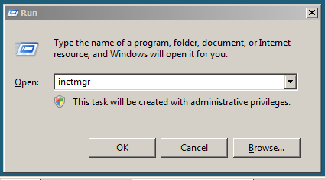](http://krismanohar.com/blog/wp-content/uploads/2010/04/inetmgr_run.png)

**To start IIS Manager from the Start Menu**

a) On the Start Menu Click on Administrative tools, and then click on Internet Information Systems (IIS) Manager.

[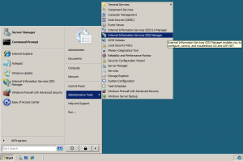](http://krismanohar.com/blog/wp-content/uploads/2010/04/iis7.png)

**To start IIS Manager from the Administrative Services console**

a) On the Start menu, click All Programs, click Accessories, and then click Run.

b) In the Run text box, type control panel, and then click OK.

c) In the Control Panel window, click Classic View, and then double-click Administrative Tools.

d) In the Administrative Tools window, double-click Internet Information Services.

When the IIS manager is started you should see a screen similar to the one below:

[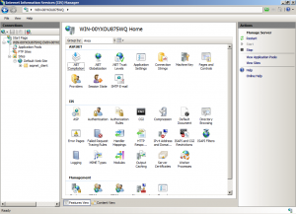](http://krismanohar.com/blog/wp-content/uploads/2010/04/iis_man.png)

To create a web site, right click on the sites node and the click on the *Add Web Site* menu option.

[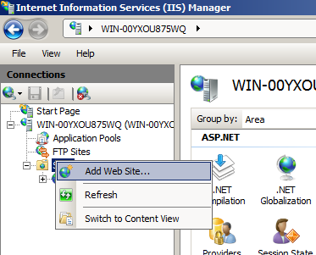](http://krismanohar.com/blog/wp-content/uploads/2010/04/add_web_site.png)

This will bring up the *Add Web Site* dialog box.

[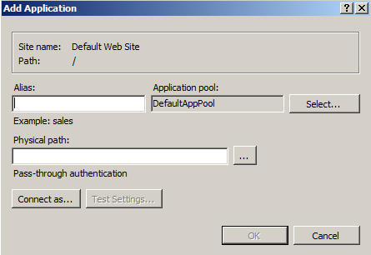](http://krismanohar.com/blog/wp-content/uploads/2010/04/add_app_dia.png)

Under site name you can enter a friendly name for the web site. The physical paths is the location on the hard disk of the root directory for this particular web site. Usually, you keep all the files for websites in separate folders under c:\inetpub\wwwroot. For this example, a folder named *service* was created, in the wwwroot folder. All the files needed for the web service then copied to that directory. Hence the value of physical path for this example would be c:\inetpub\wwwroot\service.

Binding.

Each website needs to be bound to a protocol, IPaddress, port and host name. This combination of protocol, IPaddress, port and host name tells the web server what type of requests it will handle. All of this information *together*describes a binding. If there were 2 entries for binding where every thing was the same except for the port number, that would be considered as 2 different bindings.

*//Some information on the different parts of the binding here…not to clear…on the ip //address portion and its uses.*

*//bit about blank host name means localhost, if putting in custom hostname need to*

*//edit the host file in the*[*%SystemRoot%*](http://en.wikipedia.org/wiki/Environment_variable#System_path_variables)*\system32\drivers\etc\ to resolve the hostname*

*// to an ipaddress.*

After entering all the necessary information, the add web site dialog box should look something like this:

*//image here with how the dialog box should look*

Now you  can test the web service! To do this simply open up a browser and go to the hostname you entered (if left blank then enter localhost) and the name of the *.svc file which describes the web service that you are offering.

Remember if you do not have a DNS server which is able to map the host name you entered for the website,  to the IP address of the web server where the site hosted then you would not be able to access the site. In a case like this you can enter the IPaddress for the web server (that is if you know it) instead of the host name. If you know the IPaddress of the server and would still like to access the service via host name, then on the client pc, you need to ensure that the hosts file maps the host name of the web site to the ip address of the web server.

**Publishing A Web service to an existing web site.**

This task is much simpler. The first step is to add an Application to the web site, which points to the location of the files needed for the web service. For this example the web service would be added on to the Default web site.

To add an Application

a)      Start IIS manager.

b)      Right click on the site node, then click on *Add Application*.

[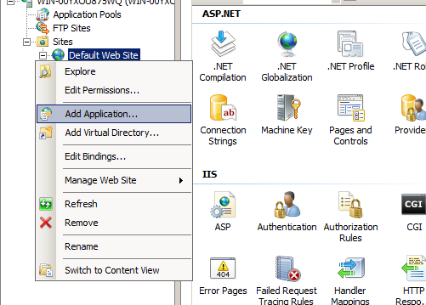](http://krismanohar.com/blog/wp-content/uploads/2010/04/add_app.png)

c)      This will bring up the Add Application dialog box.

[](http://krismanohar.com/blog/wp-content/uploads/2010/04/add_app_dia.png)

The value for the physical path is the location of where the files for the web service are stored on the server. The Alias, is the name (which is appended to the host name of the site) that the Application would be referred by.

For this example the alias would be service, and the path  : c:\inetpub\wwwroot\service.

d)      Once this is done, a file node with the alias name will appear.

[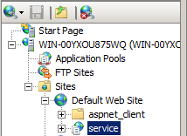](http://krismanohar.com/blog/wp-content/uploads/2010/04/app_added.png)

Now you can access the web service by entering [http://localhost/service/service.svc](http://localhost/service/service.asmx) in a web browser. Note you change localhost to the host name (if you have your host name to ip resolution working properly) or the ip address of the server, and service.svc to the name of the .svc file that describes the web service.